**Home screen**

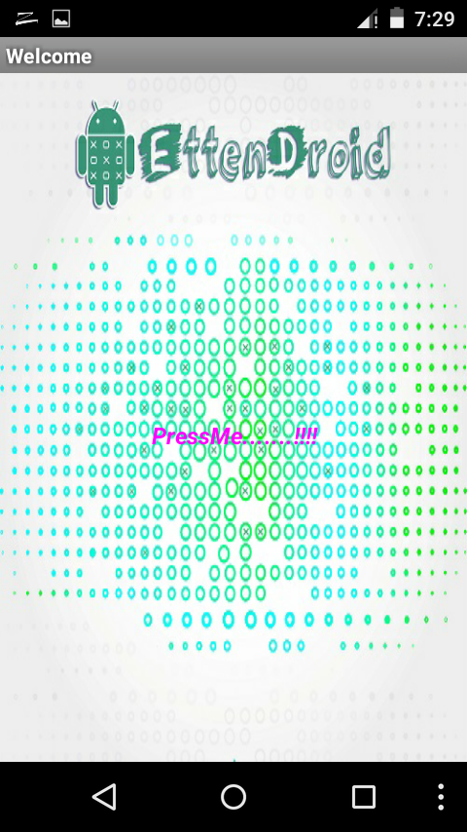

**Screen 1: Start Screen.**

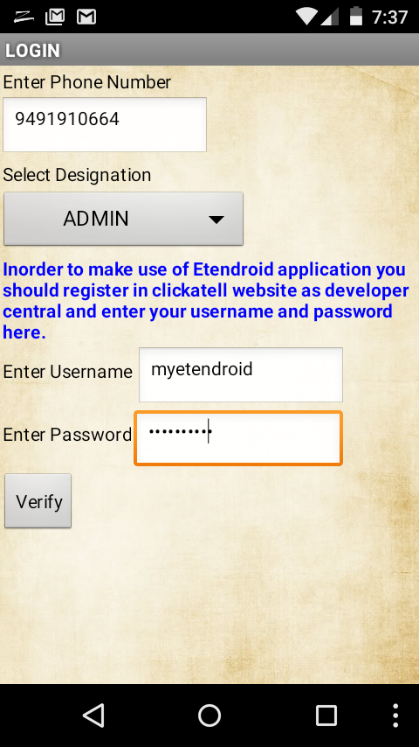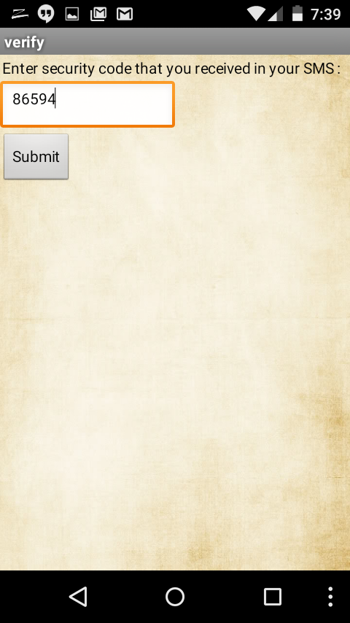

**Screen 2:** Login for Admin. Enters clickatell credentials and logins.

**Screen 3:** Verification code received through sms is entered here.

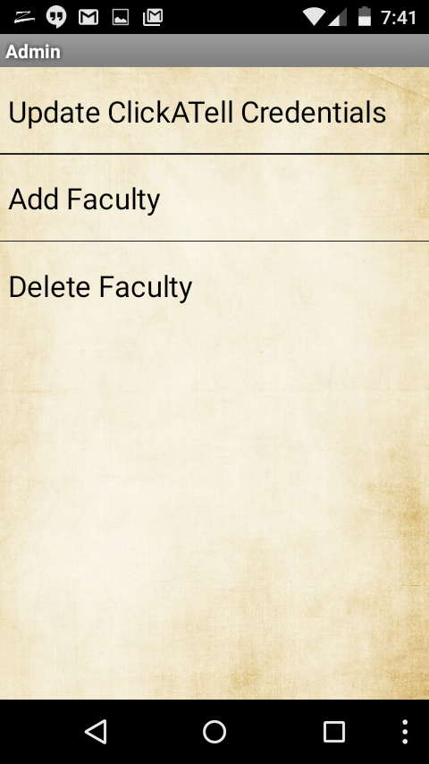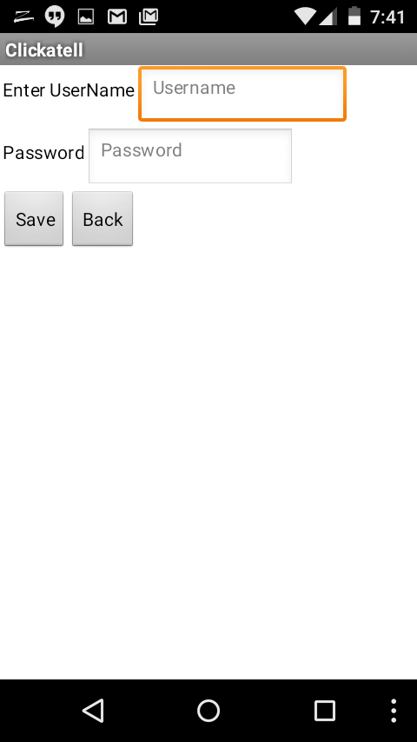

**Screen 4:** After login of admin Admin’s home screen is displayed as above.

**Screen 5**: Screen for updating clickatell credentials.

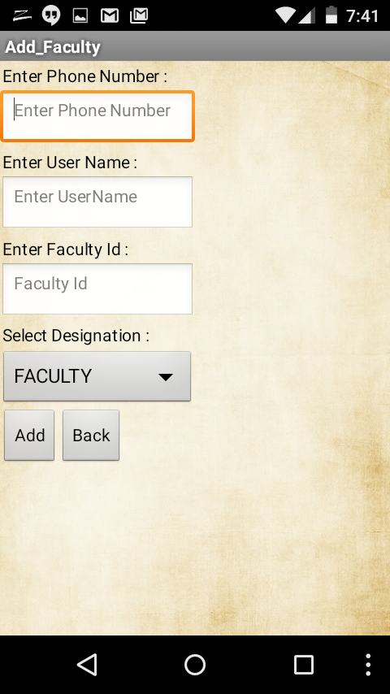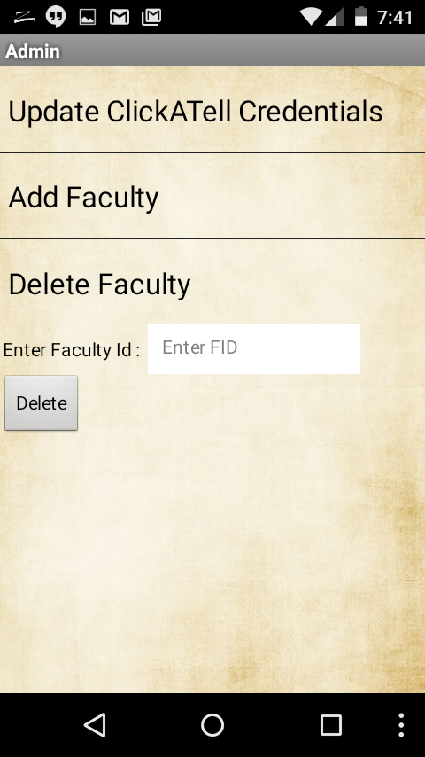

**Screen 6:** In this screen a form is displayed to fill faculty details.

**Screen 7:** How to Delete a faculty is shown in this screen.

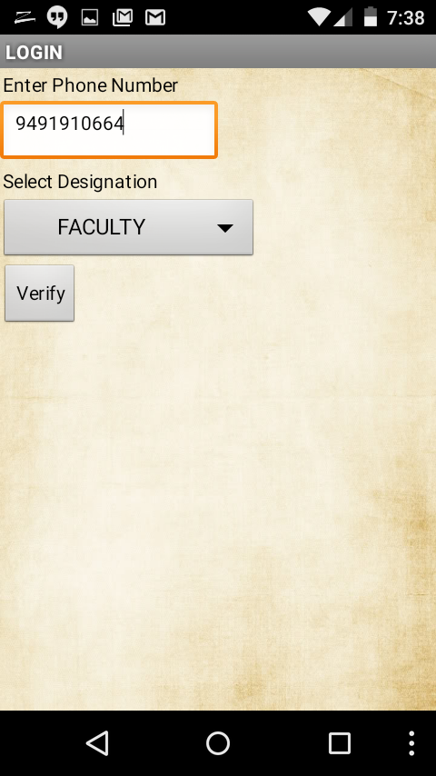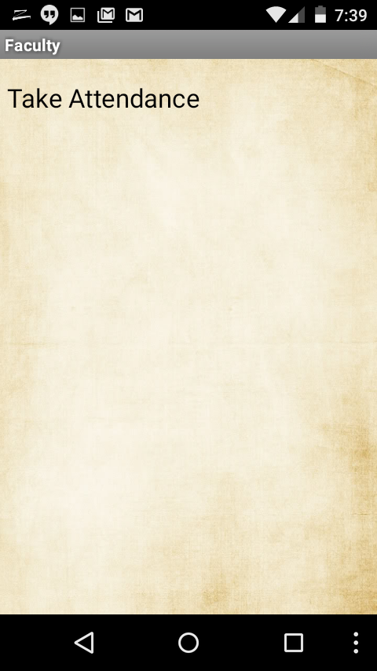

**Screen 8:** It is the login screen for faculty. He need not enter clickatell credentials.

**Screen 9:** Faculty Home Screen.

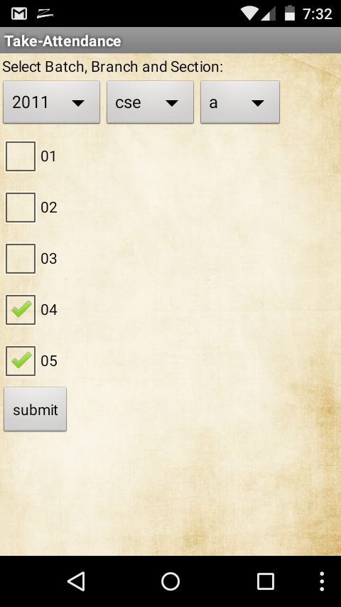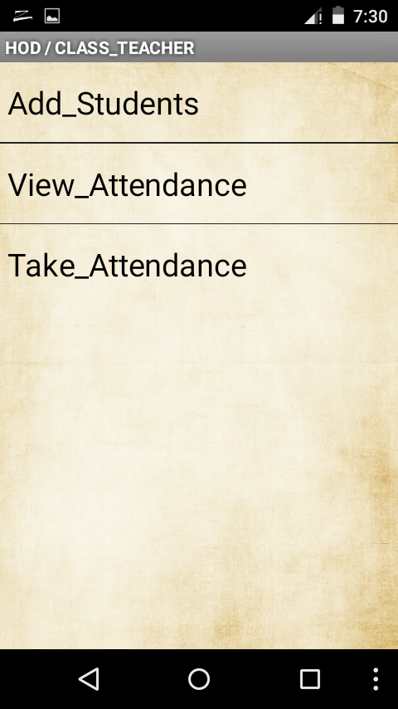

**Screen 10:** Faculty checks the absent student roll numbers and submits attendance.

**Screen 11:** Home Screen for Hod/ClassTeacher.

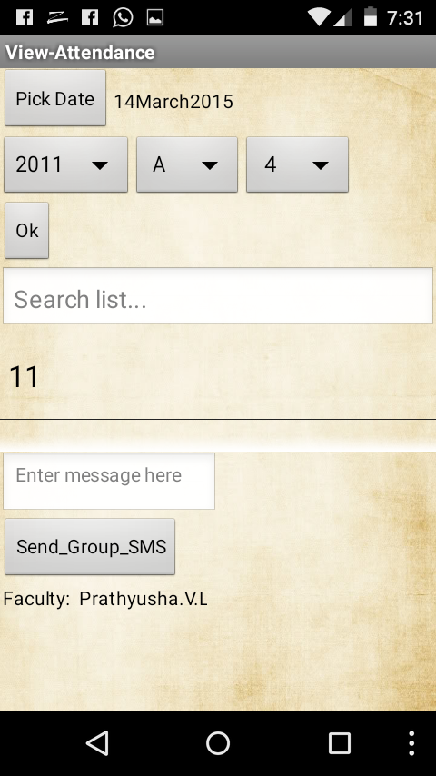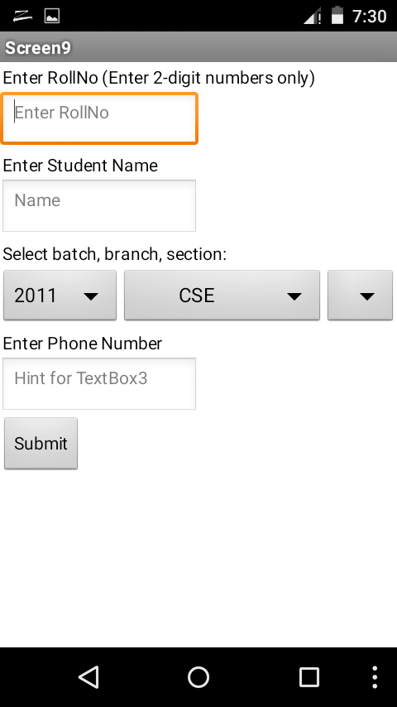

**Screen 12:** It’s the form to view student attendance by Hod/Class-Teacher.

**Screen 13:** It’s the form to add student details by class teacher.